Assignment-8 And 9 Data Structures
  - Topic->Trees and Heap
Name-Harsh
Roll no-1024030497
Batch-2C25
Ques-1
Solution->
#include <iostream>
using namespace std;
struct Node {
int val;
Node* left;
Node* right;
Node(int v): val(v), left(NULL), right(NULL) {}
};
void preorder(Node* root) {
if (!root) return;
cout << root->val << " ";
preorder(root->left);
preorder(root->right);
}
void inorder(Node* root) {
if (!root) return;
inorder(root->left);
cout << root->val << " ";
inorder(root->right);
}
void postorder(Node* root) {
if (!root) return;
postorder(root->left);
postorder(root->right);
cout << root->val << " ";
}
int main() {
Node* root = new Node(1);
root->left = new Node(2);
root->right = new Node(3);
root->left->left = new Node(4);
root->left->right = new Node(5);
cout << "Preorder: "; preorder(root); cout << endl;
cout << "Inorder: "; inorder(root); cout << endl;
cout << "Postorder: "; postorder(root); cout << endl;
}
OUTPUT
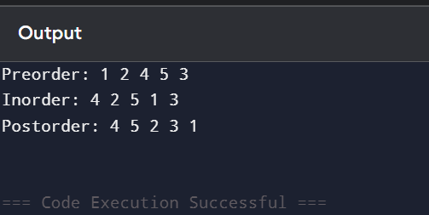
Ques-2)
Solution
#include <iostream>
using namespace std;
struct Node {
int val;
Node* left;
Node* right;
Node(int v): val(v), left(NULL), right(NULL) {}
};
Node* insert(Node* root, int key) {
if (!root) return new Node(key);
if (key < root->val) root->left = insert(root->left, key);
else if (key > root->val) root->right = insert(root->right, key);
return root;
}
Node* searchRec(Node* root, int key) {
if (!root || root->val == key) return root;
if (key < root->val) return searchRec(root->left, key);
return searchRec(root->right, key);
}
Node* searchIter(Node* root, int key) {
while (root) {
if (root->val == key) return root;
if (key < root->val) root = root->left;
else root = root->right;
}
return NULL;
}
Node* minNode(Node* root) {
while (root && root->left) root = root->left;
return root;
}
Node* maxNode(Node* root) {
while (root && root->right) root = root->right;
return root;
}
Node* inorderSuccessor(Node* root, Node* target) {
Node* succ = NULL;
while (root) {
if (target->val < root->val) {
succ = root;
root = root->left;
} else root = root->right;
}
return succ;
}
Node* inorderPredecessor(Node* root, Node* target) {
Node* pred = NULL;
while (root) {
if (target->val > root->val) {
pred = root;
root = root->right;
} else root = root->left;
}
return pred;
}
int main() {
Node* root = NULL;
root = insert(root, 50);
insert(root, 30);
insert(root, 70);
insert(root, 20);
insert(root, 40);
cout << "Min: " << minNode(root)->val << endl;
cout << "Max: " << maxNode(root)->val << endl;
Node* s = searchIter(root, 30);
cout << "Search 30: " << (s ? "Found" : "Not Found") << endl;
}
OUTPUT
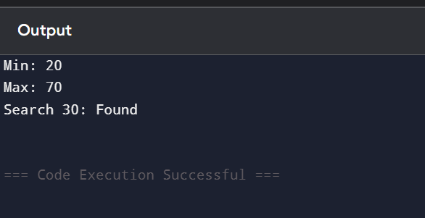
Ques-3)
Solution
#include <iostream>
using namespace std;
struct Node {
int val;
Node* left;
Node* right;
Node(int v): val(v), left(NULL), right(NULL) {}
};
Node* insert(Node* root, int key) {
if (!root) return new Node(key);
if (key < root->val) root->left = insert(root->left, key);
else if (key > root->val) root->right = insert(root->right, key);
return root;
}
Node* minNode(Node* root) {
while (root->left) root = root->left;
return root;
}
Node* deleteNode(Node* root, int key) {
if (!root) return root;
if (key < root->val) root->left = deleteNode(root->left, key);
else if (key > root->val) root->right = deleteNode(root->right, key);
else {
if (!root->left) return root->right;
else if (!root->right) return root->left;
Node* temp = minNode(root->right);
root->val = temp->val;
root->right = deleteNode(root->right, temp->val);
}
return root;
}
int maxDepth(Node* root) {
if (!root) return 0;
return 1 + max(maxDepth(root->left), maxDepth(root->right));
}
int minDepth(Node* root) {
if (!root) return 0;
if (!root->left) return 1 + minDepth(root->right);
if (!root->right) return 1 + minDepth(root->left);
return 1 + min(minDepth(root->left), minDepth(root->right));
}
int main() {
Node* root = NULL;
root = insert(root, 10);
insert(root, 5);
insert(root, 15);
insert(root, 3);
insert(root, 7);
cout << "Max Depth: " << maxDepth(root) << endl;
cout << "Min Depth: " << minDepth(root) << endl;
root = deleteNode(root, 5);
cout << "Deleted 5" << endl;
}
OUTPUT
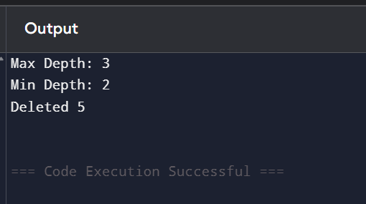
Ques-4)
Solution
#include <iostream>
using namespace std;
struct Node {
int val;
Node* left;
Node* right;
Node(int v): val(v), left(NULL), right(NULL) {}
};

bool isBSTUtil(Node* root, Node* minN, Node* maxN) {
if (!root) return true;
if (minN && root->val <= minN->val) return false;
if (maxN && root->val >= maxN->val) return false;
return isBSTUtil(root->left, minN, root) && isBSTUtil(root->right, root, maxN);
}
bool isBST(Node* root) {
return isBSTUtil(root, NULL, NULL);
}
int main() {
Node* root = new Node(10);
root->left = new Node(5);
root->right = new Node(20);
root->left->left = new Node(2);
root->left->right = new Node(8);
cout << (isBST(root) ? "BST" : "Not BST") << endl;
}
OUTPUT
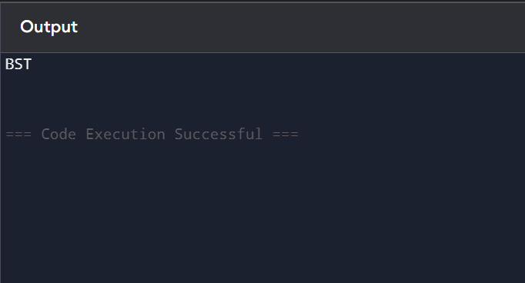
Ques-5)
Solution
#include <iostream>
#include <vector>
#include <algorithm>
using namespace std;
void heapify(vector<int>& arr, int n, int i) {
int largest = i, l = 2*i+1, r = 2*i+2;
if (l < n && arr[l] > arr[largest]) largest = l;
if (r < n && arr[r] > arr[largest]) largest = r;
if (largest != i) {
swap(arr[i], arr[largest]);
heapify(arr, n, largest);
}
}
void heapSort(vector<int>& arr, bool increasing=true) {
int n = arr.size();
for (int i=n/2-1;i>=0;i--) heapify(arr,n,i);
for (int i=n-1;i>0;i--) {
swap(arr[0],arr[i]);
heapify(arr,i,0);
}
if (!increasing) reverse(arr.begin(), arr.end());
}
int main() {
vector<int> arr = {4,10,3,5,1};
heapSort(arr,true);
for(int x:arr) cout<<x<<" "; cout<<endl;
heapSort(arr,false);
for(int x:arr) cout<<x<<" "; cout<<endl;
}
OUTPUT
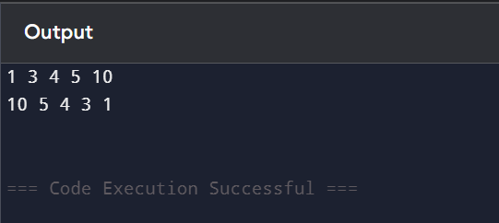
Ques-6)
Solution
#include <iostream>
#include <vector>
using namespace std;
class PriorityQueue {
vector<int> heap;
void heapify(int i) {
int n = heap.size();
int largest = i, l = 2*i+1, r = 2*i+2;
if (l < n && heap[l] > heap[largest]) largest = l;
if (r < n && heap[r] > heap[largest]) largest = r;
if (largest != i) {
swap(heap[i], heap[largest]);
heapify(largest);
}

